Canon Juniors Academy Webinar Links

- Please follow the steps below each week to sign in to the virtual classes
- Please see excel spreadsheet f (that was included in the email along with this instruction sheet) for all 10 weeks links for Big Marker virtual classes
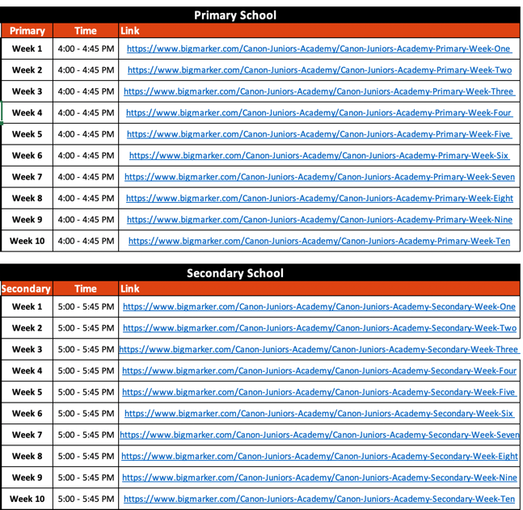

- Click on the blue links (if your primary level then click on the primary school links and if your secondary level then click on the secondary school links). This will give you access to that class for that week

- Once you click the blue link it will take you to your default web browser and you will see the photo below. Please click the register button shown here with the blue arrow
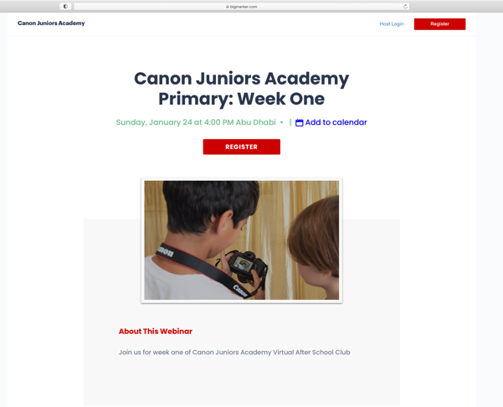

- This will now take you to a registration form. All the fields need to be filled in(see photos below)
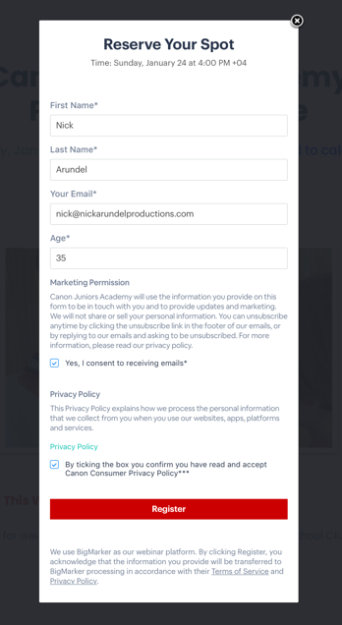
- When you click register it will take you to another web page where you will receive the link to enter into the webinar. Click this link
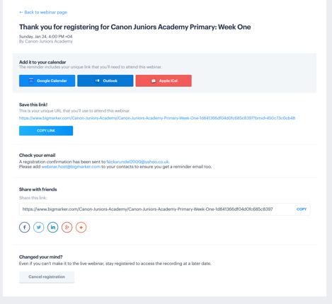

- You will also be sent an email that will also have these details on if you have a problem with the web page
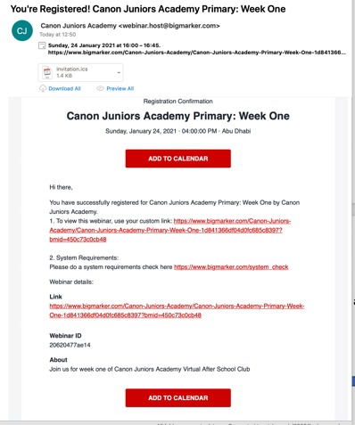

- Click the link to take you to the webinar page. It is the same page as the registration. It will say you are in the waiting room…Session will start in XX mins and XX secs.
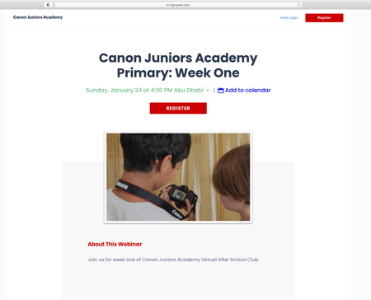

- Once the session is open it will ask you to enter. Click enter.
- It will ask you if you would like your camera on. Please make sure this is turned OFF.
- It will ask if you would like your audio turned on. Please turn your audio/mic OFF.
- You will now enter into the webinar

THESE STEPS NEED TO BE COMPLETED EVERY WEEK TO JOIN THE VIRTAUL CLASSES

